Experiment-11

Procedures

1.Create a table with attributes students and marks

Insert values into tables



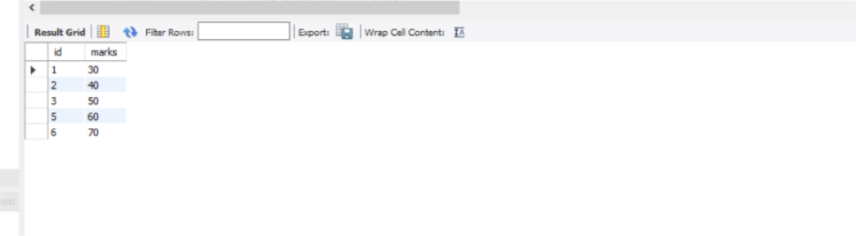

* Create a procedure to get the merit students(marks>50)
* Create a procedure to get marks of a given id(using in)

